Using Geography to Map Hospice Need in Yorkshire and Humber
Choropleth Mapping
Using the table below colour code each of the local authorities in Yorkshire and Humber to produce a choropleth map showing the prevalence of life limiting conditions in our region (remember to complete the key and give the map a title).
Local Authority | Prevalence per 10000 population
1. Barnsley | 31.6
2. Bradford | 42.4
3. Calderdale | 33.0
4. Craven | 24.3
5. Doncaster | 34.2
6. East Riding of Yorkshire | 22.0
7. Hambleton | 28.8
8. Harrogate | 23.6
9. Kingston upon Hull, City of | 26.5
10. Kirklees | 31.5
11. Leeds | 24.0
12. North East Lincolnshire | 29.2
13. North Lincolnshire | 25.5
14. Richmondshire | 23.0
15. Rotherham | 31.0
16. Ryedale | 19.9
17. Scarborough | 21.0
18. Selby | 22.5
19. Sheffield | 35.8
20. Wakefield | 28.1
21. York | 20.8

Describing Geographical patterns
Use your completed map to write a paragraph to describe the pattern of life limiting conditions in Yorkshire and Humber. Include:
- Which location has the lowest prevalence of life limiting conditions in Yorkshire and Humber
- Which local authority has the highest prevalence of life limiting conditions in Yorkshire and Humber
- Compass directions to describe the pattern shown in the map

Map showing

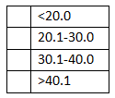
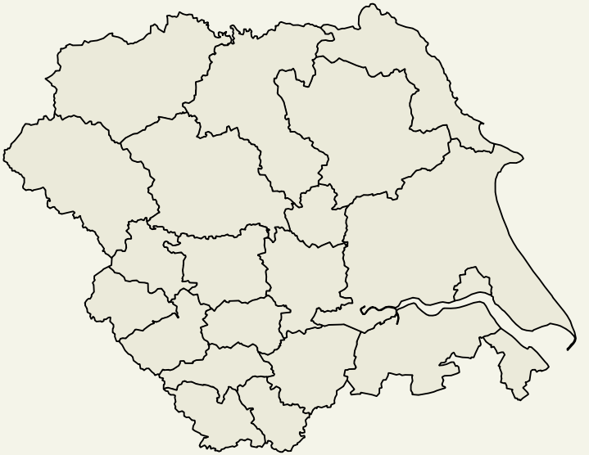
Key
21
20
19
18
17
16
15
14
13
12
11
10
9
8
7
6
5
4
3
2
1

Your opinion
- Where are the areas that might have the most demand for children’s hospices based on life limiting conditions in Yorkshire and Humber? Justify your answer with facts/figures.
- Watch the Russell House video (link below). Why are hospices so important for families affected by life limiting conditions?
https://www.forgetmenotchild.co.uk/about-us/videos/detail/russell-house-video
- Write a letter to your local M.P. to explain why Bradford needs hospice funding from the government based on your Geographical study today. Remember to use facts from the mapping at the start of the lesson but also include why hospice care is so important to families affected by life limiting conditions.

