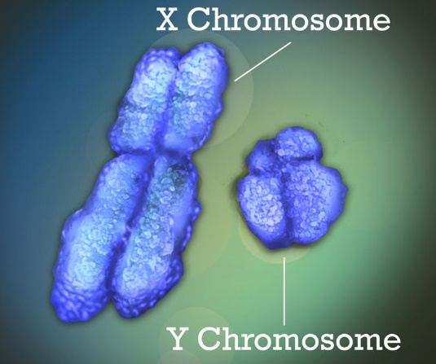
Resource 1 Life limiting disorders sheet
(ref: http://www.geneticdisordersuk.org)
ALD (Adrenoleukodystrophy)
Occurrence 1: 20,000 of the population have this disorder

ALD is caused by a genetic fault that means those affected are unable to process Very Long Chain Fatty Acids (VLCFAs). These VLCFAs are found in most vegetables and seeds, which we eat in our meals.
https://gizmodo.com

The VLCFAs accumulate and destroy the outside of our nerve cells the (myelin sheath) that covers every nerve in the body and brain. This destruction means that nervous impulses are not passed around the body properly and ALD leads to brain damage and death. When the myelin is damaged the nerves in the brain cannot work properly, and the person’s physical and mental abilities begin to deteriorate. Functions such as reasoning, speech and mobility are lost. Eventually, they become profoundly disabled.
This disorder is caused by a mutation on the X chromosome. Males have an X and a Y chromosome, females have two X chromosomes.
Boys are affected by ALD at an earlier age than girls and often have more severe symptoms. ALD affects males more than females because it is inherited through the X chromosome. Men only have one X chromosome, while women have two, so girls have less chance of having the faulty gene.
This disease appears at around 3 years old, in the most extreme cases, and healthy children start to show signs of illness, firstly through be behavioral problems, such as withdrawal or difficulty concentrating. Then, as the disease increases and causes more damage to the nerves in the brain their brain, their symptoms grow worse, including blindness and deafness, seizures, loss of muscle control, and progressive dementia. This relentless downward spiral leads to either death or permanent disability, usually within 2 to 5 years from diagnosis.
There are currently only two available treatments for ALD: Lorenzo's oil and stem cell transplantation, using either umbilical cord stem cells or bone marrow stem cells. Lorenzo’s oil is a combination of two fats extracted from olive oil and rapeseed oil. These are not cures but can delay or reduce the symptoms.

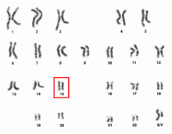
Resource 1 (ref: http://www.geneticdisordersuk.org)
Life limiting disorders sheet
TAY-SACHS
Occurrence 1: 320,000 births in the UK have this disorder

Tay–Sachs disease is an autosomal recessive genetic disorder. This means that both parents have to be carriers of the disorder (but will not show signs of it themselves). When both parents are carriers there is a 25% risk of the child being born with the illness with each pregnancy that occurs.
https://en.wikipedia.org
The child has to receive the gene for the disorder from both parents to have the disorder.
Enzymes are special proteins that help speed up all the reactions that take place in our bodies. We have enzymes for every job that our cells need to do to keep us strong and healthy. They are very specialised and they are made in our body. The pancreases makes lots of the enzymes needed to speed up the digestion of our food. Tay-Sachs is a genetic disorder caused by a defect in the HEXA gene which is needed for the production of an enzyme in the body. The HEXA gene is on chromosome 15. This enzyme is very important as it breaks down harmful waste products in the brain. If you do not have this special enzyme, the waste products build up and cause extensive damage to the brain’s nerve cells.
A child who has been diagnosed with Tay-Sachs will suffer from a deterioration of mental and physical abilities. They will become deaf, blind, will not be able to move independently or feed themselves.
Unfortunately, there is currently no cure for this disease and treatment is to make the child feel more comfortable, rather than being able to reduce the symptoms. Children do not often live past their fourth birthday.

