Resource 3: Edible DNA
You will need:
Use coloured marshmallows or jelly babies, red rope liquorice / shoe string sweets and toothpicks to construct a DNA Double Helix.
The liquorice rope will be the Backbones. The marshmallows / jelly babies will be the Bases.
Each pupil / group will need
Questions to pose to pupils?
What would we use the cocktail sticks for?
What would we use the red rope liquorice for?

• 2 pieces of liquorice / show lace sweets
• 20 to 26 coloured sweets
• 10 to 13 toothpicks
Suggested sweets for base pairs: edible bases
A (adenine) – red
The proteins always go together in specific pairs T:A and C:G, but it doesn’t matter which side they go on.
Make you own sequence – how many variations can you get in one class?
T (thymine) – black
C – (cytosine) orange
G – (guanine) green
1.
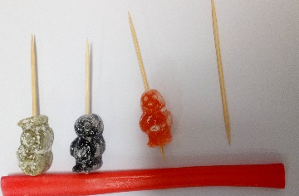
Method:
- Put together one side of your DNA Double Helix (ladder) using the sequence above. Place a sweet that matches the correct base (using the colour code chart above) on the end of a toothpick and then push the cocktail stick onto the show lace.
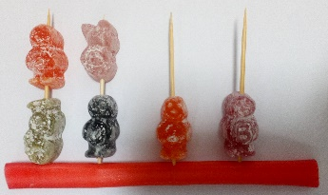
2.
- Match the chemical base pairs. Place the coloured sweet for the matching chemical base on the other end of each cocktail stick. Remember A always pairs with T and C always pairs with G

- To complete your DNA double helix. Attach the other backbone (shoe lace sweet) so your model looks like a ladder.
3.

- Twist your DNA sweet model to make an alpha helix. Be careful.
4.

