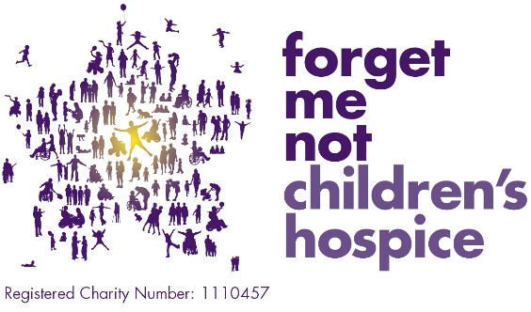

LOTTERY EXCLUSION FORM

Please exclude me from your lottery with immediate effect and do not make any direct contact with me during my exclusion period.

We will exclude you for a minimum period of 6 months from the date of the form unless you choose a longer period.

Name:
Address:
Email:
Telephone Number:
Membership Number:
Lottery Numbers:
Period of self-exclusion if longer than 6 months:
Comments:
Please return the form to:

Forget Me Not Lottery
Furness Gate
Furness Business Park
Barrow in Furness
LA14 2PE

Or email to forgetmenotweeklyprizedraw@sterlinglotteries.co.uk

I understand that:
if I attempt to enter/play any Forget Me Not Children’s hospice gambling products during the term of the exclusion and am identified by a member of staff I will be refused entry and any stake will be returned to me.
I understand my responsibility in ensuring adherence to this agreement. I acknowledge that Forget Me Not, its employees or agents have no liability or claims arising from my voluntary use of the gambling facilities provided.
Any self-exclusion may, on request, be extended for one or more further periods of at least 6 months each.

At the end of the period chosen, the self-exclusion remains in place for a further 6 months, unless I take positive action in order to gamble again.

Where I choose not to renew the self-exclusion, and make a positive request to begin gambling again during the 6 month period following the end of your initial self-exclusion, I will be given one day to cool off before being allowed access to gambling facilities. Contact must be made with the Forget Me Not Responsible Person via telephone before this can happen.

Notwithstanding the expiry of the period of self-exclusion chosen by myself, no marketing material should be sent unless and until I have asked for or agreed to accept such material.

Signature:
Date:

Support for problem gambling can be found at
- The Responsible Gambling Trust
- Be Gamble Aware
- GamCare

Software is available to prevent access to gambling internet sites see for further details https://www.begambleaware.org/gambling-blocking-software

Responsible Persons Mr Gareth Pierce & Nicola O’Dowd on 01484 411040, via email contact@forgetmenotchild.co.uk or in writing at Forget Me Not Children’s Hospice, Russell House, Fell Greave Road, Huddersfield, HD2 1NH.

